MILESTONE 3 REPORT

SOFTWARE ENGINEERING PROCESS & TOOLS

**Peer Review**

Contribution:

David Blanch: 25%

Nam Le: 25%

Rodrigo Rojas: 25%

Winston: 25%

**List of Tasks Done for Each Member**

David: Back-end implementation such as creating bookings, cancelling bookings, marking bookings as finished, get and set services and many more

Nam: Back-end implementation for contact us page, debugging back-end code , unit testing for back-end implementation, clickup and backlog, JWT tokenizing

Winston: Front-end implementation of adding services, contact us page, creating bookings, creating Junit tests, applying JWT tokenizing and CSS on all pages

Rodrigo: Front-end implementation of adding services, creating bookings, cancelling bookings, marking bookings as finished, viewing bookings and Junit tests.

**ClickUp**

https://app.clickup.com/6916083/v/l/s/6939300

**AWS Deployment**

**Vision**

Our product aims to provide both customers and business owners a platform to interact and create business opportunities. In our product, a user can be both a customer and business owner by creating two accounts of type admin and customer. When a user creates an account of type admin, our website assumes you are running a contract business with us through our platform. Our platform also allows business owners to create accounts for workers and organizing their shifts on our website, avoiding the need to use another platform for setting their workers shifts.

Business owners are allowed to create and name their own services, opening up countless possibilities to attract different customer base into our platform. This website allows creation of services where the business owners specify what their services are but if any of the services conflicts with our policy, the service will immediately be taken down.

Enough with how our platform can boost business owners cash flow, this platform also provides countless privilege to our customers. Customer can select services from whichever company that is registered in our system to satisfy their needs. Customer are allowed to choose a specific worker by booking a specific timeslot when the worker is available as well.

Furthermore, customers are allowed to cancel their bookings up to 48 hours before the booking time and a complete refund will be given to our customers, assuring convenience in time changes when unexpected situations occur for the customers.

In conclusion, our website allow both customers and business owners to interact and do business through our platform, providing both party benefits ranging from variety of services, affordability on arranging worker shifts, providing information of each and every company and many more.

**Gitflow Overview**

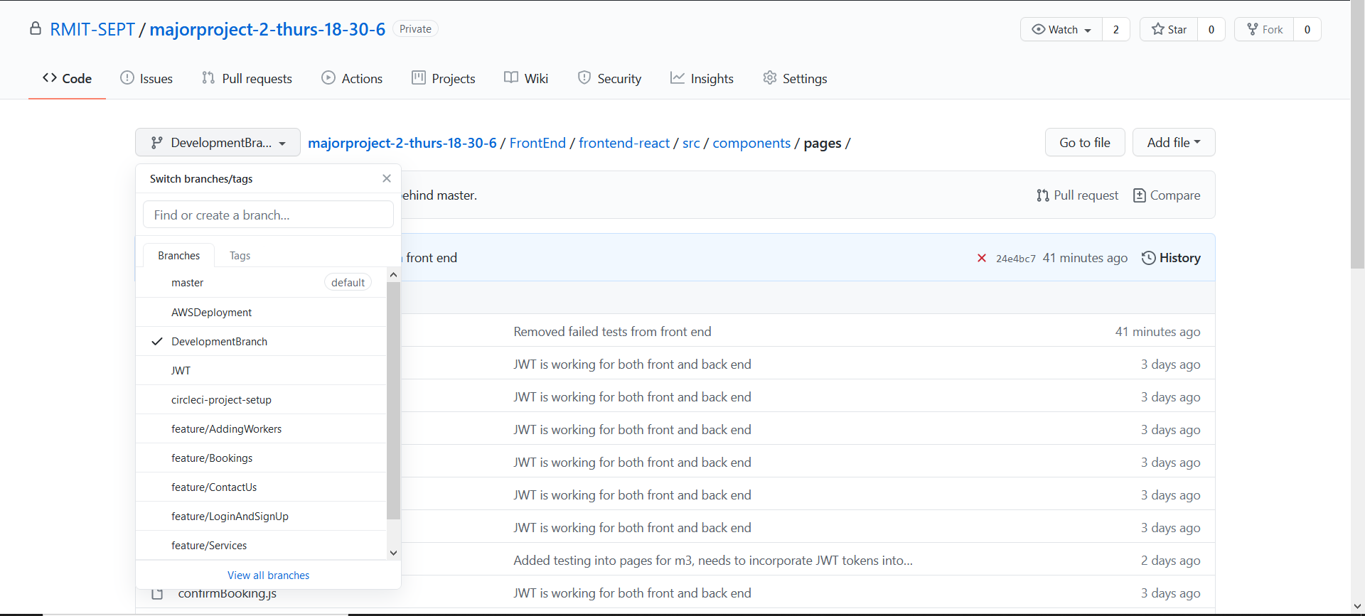

In managing our gitflow, we created a Development branch that was derived from the master branch at the initial commit, then from there onwards, we created feature branches derived from the development branches. The first branch was the feature/LoginAndSignUp which consist of the login and sign up functionality, we decided to have both login and sign up together because they share a large amount of code together. The second branch is the feature/AddingWorkers branch where admin can add workers into the system. The third branch was the feature/WorkerAvailability which has the worker setting their availability functionality and admin being able to see the workers availability functionality. As the three feature branches are finished, we merged them into the development branch while resolving some merge conflicts and then merged it into the master branch and released a tag for Milestone 2.

After releasing the tag for Milestone 2, we began working on Milestone 3 where we create another three feature branches, feature/Services where admin can add services and customer can view services functionality is implemented, feature/Bookings where everything that has to do with bookings such as making a booking, cancelling a booking, viewing a booking and marking a booking as finished functionality is implemented and lastly, feature/ContactUs branch where the contact us page is made. All three branches are merged into the development branch as the functionality and tests were completed.

**Scrum Process**

In our scrum process, we made sure to have at least 2 meetings to update each member on the progress we have made. We made use of click up to manage what should be done for the week and used Microsoft teams to communicate and arrange our scrum meetings for weekly meetings.

Winston took the scrum master position and was the one responsible in managing team scrum meetings, due dates on functionality and was in charge of directing the scrum meetings. Rodrigo as product owner was responsible for managing the backlog items assisting Nam Le and was in charge of communicating with Reza to deliver the best possible product that satisfies the client. Nam as Unit Tester worked with David to assure all back end and front- end unit testing works as intended. David as the code manager worked together with Nam to ensure that the codes are well designed to improve readability.

**Documentation of Tests**